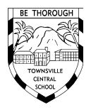
Townsville Central State School

2024-2026
Student
Code of Conduct
Every student succeeding
Every student succeeding is the shared vision of Queensland state schools. Our vision shapes regional and school planning to ensure every student receives the support needed to belong to the school community, engage purposefully in learning and experience academic success.
Queensland Department of Education
State Schools Strategy 2020-2024

Contact Information

Postal address: | 4-6 Warburton St, North Ward, Queensland 4810
Phone: | 07 47226333
Email: | admin@townsvillecentralss.eq.edu.au
School website address: | https://townsvillecentralss.eq.edu.au/
Contact Person: | Damien Tillack (Principal)

Endorsement

Principal Name: | Damien Tillack
Principal Signature:
Date: | 15 Nov 2024
P&C President Name: | Owen Petersen
P&C President Signature:
Date: | 15 Nov 2024

Contents

Purpose 4

Acknowledgement of Country 4

Principal’s Foreword 5

P&C Statement of Support 6

School Captains’ Statement 7

Consultation 7

Data Overview 8

Learning and Behaviour Statement 10

Multi-Tiered Systems of Support 10

Consideration of Individual Circumstances 11

Student Wellbeing 12

Student Support Network 14

Whole School Approach to a Positive Culture for Learning (PCL) 14

Positive Behaviour for Learning (PBL) Expectations 15

Restorative Practices 18

Differentiated and Explicit Teaching 20

Focussed Teaching 20

Intensive Teaching 21

Disciplinary Consequences 22

School Disciplinary Absences (SDAs) 24

School Policies 27

Temporary removal of student property 27

Use of mobile phones and other devices by students 29

Preventing and responding to bullying 30

Appropriate use of social media 40

Restrictive Practices 42

Critical Incidents 43
Appendices 44

Purpose

Townsville Central State School is committed to providing a safe, respectful and disciplined learning environment for all students, staff, parents and visitors.

The Townsville Central State School Student Code of Conduct sets out the responsibilities and processes we use in our school to promote a productive, effective whole school approach to discipline.

Its purpose is to facilitate high standards of behaviour from all in the school community, ensuring learning and teaching in our school is prioritised, where all students are able to experience success and staff enjoy a safe workplace.

Acknowledgement of Country
By Townsville Central State School students


 are at the base of Castle Hill, Cutheringa, across the
bay from Magnetic Island, Yunbanun. We 
s of Townsville, Gurambilburra 
 a 
We also acknowledge that Australia's Indigenous peoples were our first scientists, first educators
and first researchers. , and 

Principal’s Foreword

Townsville Central State School is the oldest school in Townsville and celebrated its 150th birthday in March 2019. Situated on the site of the original gaol with Castle Hill and Queens Gardens in the background and The Strand just down the road, our school has arguably the best location in the area.
Our school values are Wonder I Teamwork I GEM (Gratitude Empathy Mindfulness) I Acceptance I Resilience.
Townsville Central State School has a dedicated and experienced staff, thoughtful and positive students and involved parents. The school maintains a strong connection to its community. Our key focus areas are improving students' achievement in reading, writing and numeracy, and improving student and staff wellbeing.
At our school, wellbeing is very important. We even have weekly Wellbeing lessons. Our pedagogical framework is based on Visible Teaching, Visible Learning, and our behaviour framework is Positive Culture for Learning (PCL), based on Positive Behaviour for Learning (PBL), Restorative Practices and the Wheel Of Wellbeing (incorporating GEM). We have lots of student clubs to foster resilience and connection to place and people.
Our school prides itself on the holistic education of our students with a suite of programs, events, celebrations and activities to build their resilience, problem-solving strategies and foster academic excellence. Students engage with the curriculum through a range of clubs that may include Coding Club, Art Club, Japanese Club, Wellbeing Club, Sporting Schools, Opti-Minds, Global Tropics Futures and a third of our students participate in our Instrumental Music Program. Sustainability has, for a long time, been an embedded practice in our school. Our students operate a variety of recycling programs.
The school population fluctuates between 170 and 200 students. Less than 50% of the students live in the school catchment area, while the rest come from other Townsville suburbs, ranging from Alligator Creek to Paluma. Many of the students who do not live in the catchment area have parents who work in the Townsville Central Business District or near the school. At least 50 students access the daily Outside School Hours Care facility. Our OSHC regularly achieves the top ranks in all domains of OSCH audits.
At Townsville Central we have a steady population of Indigenous students (20-25%), approximately 30% of our student population have a Language Background Other Than English and over 10% of students are new residents to Australia.
Our students regularly achieve to high standards, with 50%-60% achieving As and Bs each semester, and approximately 75-85% of all students achieving an A, B or C each semester for their results.
Damien Tillack
Principal

Parents and Citizens (P&C) Statement of Support

Townsville Central State School has a long history within the Townsville community with generations of families having attended the school in its 150 years of operation. Our little school has embedded itself as one of the longest running and historically rich schools in an ever changing, transient and vibrant city. In this constantly changing landscape, Townsville Central State School has continued to thrive as it grows into one of the leading schools in Townsville.
Through the introduction and implementation of our Positive Culture for Learning, Restorative Practices and The Wheel Of Wellbeing, we have been able to build a stronger connection to community which fosters a holistic approach to education for all our students. Through the ongoing support and work of our diverse and experienced leadership team, in collaboration with the Parents and Citizens Association, Townsville Central State School has seen a marked improvement across all areas of learning and behaviour management.
Our P&C Association continues to support the PCL (Positive Culture for Learning) framework, Restorative Practices and Wheel Of Wellbeing implemented at Central from 2021 - 2023.
Owen Petersen
P&C President

School Captains’ Statement

Here at Central we have a Behaviour Management Plan that all students must follow. Our behaviour is managed by having a PCL focus every week to follow for an improved mindset and to produce a well-behaved school environment.
The PCL focus helps keep students on track and their behaviour to their best. We have Assembly every Monday morning to remind the students of our PCL focus and our GEM focus to start the week off on a high note. The senior students, every other day, will go around to one class and keep them up-to-date with the PCL focus, GEM focus and the clubs on for that day.
We have wellbeing classes which teach us about positive behaviour. We also have a GEM focus which stands for Gratitude, Empathy and Mindfulness. We have a new GEM focus every week. It also creates a positive mindset in the students, resulting in a positive outcome in the students’ behaviour.
We have school leaders to assist with the students’ positive behaviour by setting a good example for the younger students. We also have the High Five which is a strategy to help kids know what to do in a bad situation. The High Five shows students the correct way deal with problems. Finally, we have a school mascot, Curtis, to teach the school rules and show younger kids what is best and express the school rules.
Sophie Andrews and Maverick Speers
2020 School Captains
Monique Steenson and Benjamin Parsons
2020 School Vice-Captains

Consultation

The P&C, staff and student body was involved in the drafting phases. This committee draws members from all roles in the school. Staff were consulted on the Student Code of Conduct. School captains contributed. The P&C also contributed with reviews connecting behaviour support between school and OSHC. Past School Opinion Surveys data were also used to guide decisions.

Data Overview

This section is used to report on key measures related to student discipline, safety and wellbeing using existing data sets available to all schools. This provides an open and transparent reporting mechanism for the school community on the perceptions of students, parents and staff about school climate, attendance and school disciplinary absences.

The Parent, Student and Staff Satisfaction data in the tables below is drawn from the School Opinion Survey. The School Opinion Survey is an annual collection designed to obtain the views of parents/caregivers, students and school staff from each school on what they do well and how they can improve. There are four different confidential surveys for: parents, students, staff, and principals.

Opinions on the school as a workplace are sought from all school staff and principals. There are additional questions for teaching staff on their confidence to teach and improve student outcomes. Principals are also asked about their confidence to lead the school and improve student outcomes. Due to COVID-19, there is no data for 2020.

Percentage of students who agree# that: | 2017 | 2018 | 2019
- they are getting a good education at school (S2048) | 100% | 96% | 97%
- they like being at their school* (S2036) | 93% | 100% | 97%
- they feel safe at their school* (S2037) | 87% | 82% | 90%
- their teachers motivate them to learn* (S2038) | 93% | 100% | 95%
- their teachers expect them to do their best* (S2039) | 100% | 100% | 97%
- their teachers provide them with useful feedback about their school work* (S2040) | 98% | 98% | 95%
- teachers treat students fairly at their school* (S2041) | 88% | 90% | 89%
- they can talk to their teachers about their concerns* (S2042) | 93% | 96% | 94%
- their school takes students' opinions seriously* (S2043) | 88% | 92% | 84%
- student behaviour is well managed at their school* (S2044) | 84% | 71% | 75%
- their school looks for ways to improve* (S2045) | 97% | 98% | 92%
- their school is well maintained* (S2046) | 93% | 90% | 89%
- their school gives them opportunities to do interesting things* (S2047) | 93% | 98% | 95%
* Nationally agreed student and parent/caregiver items.
# ‘Agree’ represents the percentage of respondents who Somewhat Agree, Agree or Strongly Agree with the statement.
DW = Data withheld to ensure confidentiality.

Percentage of parents/caregivers who agree# that: | 2017 | 2018 | 2019
- their child is getting a good education at school (S2016) | 85% | 100% | 100%
- this is a good school (S2035) | 85% | 100% | 100%
- their child likes being at this school* (S2001) | 90% | 100% | 100%
- their child feels safe at this school* (S2002) | 75% | 100% | 100%
- their child's learning needs are being met at this school* (S2003) | 85% | 92% | 92%
- their child is making good progress at this school* (S2004) | 85% | 92% | 92%
- teachers at this school expect their child to do his or her best* (S2005) | 90% | 100% | 100%
- teachers at this school provide their child with useful feedback about his or her school work* (S2006) | 83% | 92% | 100%
- teachers at this school motivate their child to learn* (S2007) | 79% | 100% | 85%
- teachers at this school treat students fairly* (S2008) | 75% | 92% | 92%
- they can talk to their child's teachers about their concerns* (S2009) | 95% | 100% | 92%
- this school works with them to support their child's learning* (S2010) | 85% | 92% | 100%
- this school takes parents' opinions seriously* (S2011) | 75% | 91% | 92%
- student behaviour is well managed at this school* (S2012) | 53% | 77% | 92%
- this school looks for ways to improve* (S2013) | 90% | 92% | 100%
- this school is well maintained* (S2014) | 80% | 100% | 92%
* Nationally agreed student and parent/caregiver items.
# ‘Agree’ represents the percentage of respondents who Somewhat Agree, Agree or Strongly Agree with the statement.
DW = Data withheld to ensure confidentiality.

Percentage of school staff who agree# that: | 2017 | 2018 | 2019
- they enjoy working at their school (S2069) | 90% | 81% | 96%
- they feel that their school is a safe place in which to work (S2070) | 90% | 88% | 96%
- they receive useful feedback about their work at their school (S2071) | 80% | 63% | 57%
- they feel confident embedding Aboriginal and Torres Strait Islander perspectives across the learning areas (S2114) | 100% | 92% | 100%
- students are encouraged to do their best at their school (S2072) | 89% | 94% | 96%
- students are treated fairly at their school (S2073) | 89% | 94% | 96%
- student behaviour is well managed at their school (S2074) | 89% | 75% | 78%
- staff are well supported at their school (S2075) | 80% | 81% | 61%
- their school takes staff opinions seriously (S2076) | 90% | 75% | 70%
- their school looks for ways to improve (S2077) | 100% | 100% | 87%
- their school is well maintained (S2078) | 90% | 88% | 74%
- their school gives them opportunities to do interesting things (S2079) | 100% | 75% | 82%
* Nationally agreed student and parent/caregiver items.
# ‘Agree’ represents the percentage of respondents who Somewhat Agree, Agree or Strongly Agree with the statement.
DW = Data withheld to ensure confidentiality.

Learning and Behaviour Statement

Everyone brings their own sets of personal beliefs to a school community. These beliefs influence their decisions, behaviour and social practices. It is reasonable to expect that not everyone will share the same sets of beliefs, and this contributes to a richly diverse social environment in each school. It can also contribute to differences in expectations and force us to reflect on our own understanding of what we consider acceptable and unacceptable. We encourage any student or parent to make an appointment with the principal to discuss the model of behaviour support and discipline used at this school.

Multi-Tiered Systems of Support

Townsville Central State School uses multi-tiered systems of support (MTSS) as the foundation for our integrated approach to learning and behaviour. MTSS is a preventative, differentiated model grounded in practical strategies, targeted planning and data-informed decision-making. Based on a problem-solving model, in MTSS school staff match increasingly intensive interventions to the identified needs of individual students.

Tier | Prevention Description
1 | All students (100%) in the school receive support for their academic and behavioural development. Focus is on the whole-school implementation of both the Australian Curriculum and Positive Behaviour for Learning (PBL) expectations. This involves:  - teaching behaviours in the setting they will be used  - being consistent when addressing challenging behaviour, while taking developmental norms and behavioural function into account  - providing refresher lessons and targeted recognition throughout the school year so skills are ready and likely to be used when students need them  - asking students and their families for their perspectives on school climate, instruction, reinforcement, and discipline so improvements in Tier 1 may be made.
2 | Targeted instruction and supports for some students (10-15%) are more intense that Tier 1 services, providing more time and specialisation in services from a range of school-based staff to enable students to meet the required academic and behavioural standards.  Tier 2 supports build on the lessons provided at Tier 1, and may prevent the need for more intensive interventions. Tier 2 supports are provided to small groups of students with similar needs, offering more time and/or detailed instruction on the Australian Curriculum or particular aspects of Positive Behaviour for Learning (PBL) expectations. The types of interventions offered at this level will vary according to the needs of each school’s student body, but all have certain things in common:  - there is a clear connection between the skills taught in the interventions and the school-wide expectations.  - interventions require little time of classroom teachers and are easy to sustain  - variations within each intervention are limited  - interventions have a good chance of working (e.g., they are “evidence-based” interventions that are matched to the student’s need).  If the school data indicates that more than 10-15% of students require targeted services, then a review of Tier 1 is needed to address the basic implementation and quality of instruction.
3 |  | Individualised services for few students (2-5%) who require the most intensive support a school can provide. These are usually delivered in very small groups or on an individual basis.  Tier 3 supports continue to build on the lessons and supports provided at Tiers 1 and 2, becoming more individualised and more intensive until teams can identify what is needed for a student to be successful. Tier 3 supports are based on the underlying reasons for a student’s behaviour (their FBA) and should include strategies to:  - PREVENT problem behaviour  - TEACH the student an acceptable replacement behaviour  - REINFORCE the student’s use of the replacement behaviour  - MINIMISE the payoff for problem behaviour.  Tier 3 supports exist along a continuum. Many students can benefit from a simple (or brief) Functional Behaviour Assessment (FBA) that identifies unique strategies to help the student achieve success. A smaller percentage of students may require a more comprehensive FBA that includes a more thorough process for data collection, teaming, and problem solving. A much smaller percentage of students may need an intensive FBA and wraparound plan that includes personnel from outside agencies and rigorous problem solving procedures.  If the school data indicates that more than 2-5% of the student population requires individualised services, a review of Tier 1 and Tier 2 supports and organisation is recommended.

Consideration of Individual Circumstances

Staff at Townsville Central State School take into account students’ individual circumstances, such as their behaviour history, disability, mental health and wellbeing, religious and cultural considerations, home environment and care arrangements when teaching expectations, responding to inappropriate behaviour or applying a disciplinary consequence.

In considering the individual circumstances of each student, we recognise that the way we teach, the support we provide and the way we respond to students will differ. This reflects the principle of equality, where every student is given the support they need to be successful. This also means that not everyone will be treated the same, because treating everyone the same is not fair. For example, some students need additional support to interpret or understand an expectation. Others may benefit from more opportunities to practise a required skill or behaviour. For a small number of students, the use of certain disciplinary consequences may be considered inappropriate or ineffective due to complex trauma or family circumstances. These are all matters that our teachers and principal consider with each individual student in both the instruction of behaviour and the response to behaviour.

Our teachers are also obliged by law to respect and protect the privacy of individual students, so while we understand the interest of other students, staff and parents to know what punishment another student might have received, we will not disclose or discuss this information with anyone but the student’s family. This applies even if the behavioural incident, such as bullying, involves your child. You can be assured that school staff take all matters, such as bullying, very seriously and will address them appropriately. We expect that parents and students will respect the privacy of other students and families.

If you have concerns about the behaviour of another student at the school, or the way our staff have responded to their behaviour, please make an appointment with the principal to discuss the matter.

Student Wellbeing

Townsville Central State School offers a range of programs and services to support the wellbeing of students in our school. We encourage parents and students to speak with their class teacher or make an appointment to meet with the guidance officer if they would like individual advice about accessing particular services.

At Townsville Central, we foster the factors of resilience in children, and one of these ways is through school clubs, where students find belonging and connectedness, as well as developing their exception story and build vocabulary. Our clubs include (but are not limited to) Choir, Coding Club, Art Club, Art and Craft Club, Junior Aboriginal and Torres Strait Islander Aspirations Program (ATSIAP) Club, Japanese Club, Wellbeing Club, Chess Club, Sporting Schools, Opti-Minds, Global Tropics Futures, and more.

Learning and wellbeing are inextricably linked — students learn best when their wellbeing is optimised, and they develop a strong sense of wellbeing when they experience success in learning. The student learning and wellbeing framework supports state schools with creating positive school cultures and embedding student wellbeing in all aspects of school life through connecting the learning environment, curriculum and pedagogy, policies, procedures and partnerships for learning and life.

Curriculum and pedagogy
Schools build the foundations for wellbeing and lifelong learning through curriculum embedding personal and social capabilities (self-awareness, self-management, social awareness and social management) in the implementation of the P–12 curriculum, assessment and reporting framework.

Schools acknowledge the positive impact that a meaningful relationship between teacher and students can have on students' academic and social outcomes. As part of the whole school's curriculum at Townsville Central State School, we provide age-appropriate health education that reinforces public health and safety messages.

Policy and expectations
Within a school community there are specific health and wellbeing issues that will need to be addressed for the whole school, specific students, or in certain circumstances.

Drug education and intervention
Townsville Central State School implements drug intervention measures for students involved in drug-related incidents at school, during school activities or while in school uniform. This is case managed within our MTSS to protect the health and safety of the student/s involved, other students, school staff and the wider community.

Specialised health needs
Townsville Central State School works closely with parents to ensure students with specialised health needs, including those requiring specialised health procedures, have access to a reasonable standard of support for their health needs whilst attending school or school-based activities.

This means that appropriate health plans are developed and followed for students with specialised health needs, that staff are aware of the student's medical condition and that an appropriate number of staff have been trained to support the student's health condition.

Medications
Townsville Central State School requires parent consent and medical authorisation to administer any medication (including over-the-counter medications) to students. For students requiring medication to be administered during school hours, the school can provide further information and relevant forms.

For students with a long-term health condition requiring medication, parents need to provide the school with a Request to administer medication at school form signed by the prescribing health practitioner.

Townsville Central State School maintains a minimum of one adrenaline auto-injector and asthma reliever/puffer, stored in the school's/campus first aid kit to provide emergency first aid medication if required.

Mental health
Townsville Central State School implements early intervention measures and treatments for students within our MTSS where there is reasonable belief that a student has a mental health difficulty. This includes facilitating the development, implementation and periodic review of a Student Plan.

An appropriate mental health first aid action plan follows these steps:
- APPROACH the person, assess and assist with any crisis
- LISTEN and communicate non-judgmentally
- GIVE support and information
- ENCOURAGE the person to get appropriate professional help
- ENCOURAGE other supports
(Youth Mental First Aid guidelines)

Suicide prevention
Townsville Central State School school staff who notice suicide warning signs in a student should seek help immediately from the school guidance officer, senior guidance officer or other appropriate staff.

When dealing with a mental health crisis, schools call 000 when there is an imminent threat to the safety of student in the first instance, and where necessary provide first aid. In all other situations, Townsville Central State School staff follow suicide intervention and prevention advice by ensuring:
- the student is not left alone
- their safety and the safety of other students and staff is maintained
- students receive appropriate support immediately
- parents are advised
- all actions are documented and reported.

Suicide postvention
In the case of a suicide of a student that has not occurred on school grounds, Townsville Central State School enacts a postvention response, by communicating with the family of the student and ensuring immediate support is provided to students and staff who may be affected.

Where a suicide has occurred on school grounds or at a school event, Townsville Central State School staff immediately enact the School Emergency Management Plan and communicate with the family of the student and ensure immediate support is provided to students and staff who may be affected.

Student Support Network

Townsville Central State School is proud to have a comprehensive Student Support Network in place to help the social, emotional and physical wellbeing of every student. In addition to the assistance provided by class teachers, we have a team of professionals whose dedicated roles are to help ensure our school is an inclusive, nurturing environment.

Students can approach any trusted school staff member at Townsville Central State School to seek assistance or advice. If they are unable to assist they will provide guidance and help ensure the student is connected to the appropriate representative of the Student Support Network.

Parents who would like more information about the student support roles and responsibilities are invited to contact the Principal.

Role
Community Education Counsellor
Guidance Officer
Registered Nurse
Class wellbeing teachers
School Chaplain
Student Services Team
HOSES

It is also important for students and parents to understand there are regional and statewide support services also available to supplement the school network. These include Principal Advisor Student Protection, Mental Health Coach, Autism Coach, Inclusion Coach, Success Coach, Advisory Visiting Teachers and Senior Guidance Officers. For more information about these services and their roles, please speak with the Principal.

Whole School Approach to a Positive Culture for Learning

At Townsville Central State School, we use an evidenced based whole school behaviour framework to develop our Positive Culture for Learning (PCL). This structure uses the Positive Behaviour for learning Framework, Restorative Practices, Wheel Of Wellbeing, Zones fo Regulation and aspects of The Resilience Project (GEM). PCL at Townsville Central focuses on explicitly teaching, modelling and practicing behavioural expectations aimed towards all students to encourage positive behaviour and learning success. It supports staff to implement and maintain consistent practices to assist with explicitly teaching students expected behaviours and facilitating standards of positive behaviour across the whole school. This whole school approach allows teachers to teach and students to learn in a safe and supported learning environment.
Townsville Central State School PCL expectations are consistent across the whole school:
- Be Safe
- Be Responsible
- Be Respectful
These expectations are visible around the school and have been developed collaboratively. They are communicated to students and the wider school community through a number of strategies, including:
- School Mascot ‘Curtis the Cokckatoo’ – promoting expectations
  - Around the school
  - In classrooms (Class Rules, Consequences Chart)
- Visible representations in all learning areas
- Weekly focus – Data driven
- Explicit teaching in PCL lessons – weekly focus
- Weekly parade – reinforce weekly focus

PBL Expectations

Our staff are committed to delivering a high quality of education for every student, and believe all adults in the school, whether visiting or working, should meet the same five Positive Behaviour for Learning (PBL) expectations in place for students, being Thoughtful, Responsible, Accountable, Co-operative and Kind (TRACK).

Students
Below are examples of what these PBL expectations look like for students across the school. In addition, each classroom will have their own set of examples to help students and visitors understand the expectations and meet the standards we hold for everyone at Townsville Central State School. These are renewed on the first day of each term.

 | WHOLE SCHOOL | CLASSROOM | GROUNDS
BE SAFE | As a safe learner I:  - Move around calmly and quietly  - Use equipment for its intended purpose  - Maintain a clean and tidy environment  - Walk my bike, skateboard and scooter etc. inside the school grounds  - Keep my hands and feet to myself  - Keep myself safe on the inside of my body and the outside of my body | As a safe learner I:  - Move around calmly and quietly  - Use equipment for its intended purpose  - Follow classroom routines  - Am in the right place at all times  - Follow all staff directions first time, every time. | As a safe learner I:  - Am sun safe  - Follow outside school rules when playing outside  - Play running games on grassed areas and courts  - Stay safely at school all day  - Move around safely and calmly  - Use all equipment the right way
BE RESPECTFUL | As a respectful learner I:  - Treat others the right way and I am tolerant  - Look after all property  - Always use appropriate, respectful language  - Maintain a clean and tidy environment | As a respectful learner I:  - Use whole-body listening  - Allow everyone the right to teach and learn  - Listen, wait my turn, listen to others  - Use appropriate words and tone every time | As a respectful learner I:  - Take turns and play fairly  - Do the right activity in the right place  - Use manners when speaking with others
BE RESPONSIBLE | As a responsible learner I:  - Wear the full school uniform correctly  - Attend school because every day counts  - Am on time, every time  - Follow staff directions  - Own my behaviour and I reflect on my behaviour  - Care for others | As a responsible learner I:  - Am in class and on task  - Bring all necessary equipment to all my classes  - Complete all tasks to the best of my ability  - Turn off electronic devices and take them to the office  - Ask for help in the right way when I need it. | As a responsible learner I:  - Place all litter in the bin  - Move back to my class line on the bell  - Am considerate of others  - Stay in the right place, at the right time.  - Sit and eat during Eating Time

Parents and staff
The table below explains the PBL expectations for parents when visiting our school and the standards we commit to as staff.

Be Safe

What we expect to see from you | What you can expect from us
Express an active interest in your child’s schooling and progress. | Provide safe and supportive learning environments.
Support school staff in maintaining a safe and respectful learning environment for all students. | Provide inclusive and engaging curriculum and teaching.

Be Respectful

What we expect to see from you | What you can expect from us
Support school staff in maintaining a safe and respectful learning environment for all students. | Provide inclusive and engaging curriculum and teaching.
Initiate and maintain constructive communication and relationships with school staff regarding your child’s learning, wellbeing and behaviour. | Initiate and maintain constructive communication and relationships with students and parents.

Be Responsible

What we expect to see from you | What you can expect from us
You respect the obligation of staff to maintain student and family privacy. | We will maintain confidentiality about information relating to your child and family.
You ensure your children attend school every day and notify the school promptly of any absences or changes in contact details. | We will create a safe, supportive and inclusive environment for every student.
You recognise people are different and will be non-judgemental, fair and equitable to others in the school community. | We will welcome and celebrate a diverse school community with recognition of significant social, cultural and historical events.

Respectful Relationships Matrix

VALUE | SCHOOL | CLASSROOM | PLAYGROUND
RESPECTFUL  RELATIONSHIPS | - Be positive and welcoming to community members  - Value difference  - Consider other people’s feelings – be empathetic | - Value others’ opinions  - Encourage classmates  - Be accepting of others | - Be inclusive – make sure everyone is included  - Show empathy and kindness to others  - Demonstrate sportsmanship – accept we disagree and move on

By implementing Respectful Relationships teachings, Townsville Central State School gives students opportunities for social and emotional learning in self-awareness, self-management, social awareness, relationships, ethics, values, social norms, stereotypes, human rights, risk and responsible decision-making. A growing body of evidence shows that social and emotional learning of this nature leads to:
- Improved social and emotional skills, self-concept, bonding to school and classroom behaviour.
- Less disruptive classroom behaviour, aggression, bullying and delinquent acts.
- Reduced emotional distress such as depression, stress or social withdrawal.
Restorative Practices

Restorative Practices recognises that when wrong doing occurs, relationships are damaged. For successful learning to occur, these relationships must be put right.

Following a critical incident, there is opportunity for reparation and restoration. This could take the form of a restorative chat, small group conference, classroom conference or a more formal community conference.

The Restorative Conference
Conferencing is a process which brings together, in the wake of a serious incident of harm,
the wrongdoer and those harmed along with their families and appropriate school personnel.
The purpose is to explore the harm done to all those affected, decide what needs to be done
to repair that harm and how to minimise the chance of it happening again.
The process for a conference may involve:
- Establishing the facts and deciding who should attend;
- Interviewing all participants to gather information and establish positive
relationships;
- Arranging an appropriate time and place to meet;
- Developing a seating plan, preparing for likely dynamics; and
- Using a specific ‘Conference Script” (Margaret Thorsborne 2008 ‘Restorative Practices in Schools’)

The Restorative Conversation and the Restorative Chat
The restorative conversation and restorative chat is an option to restore the relationship following a major or minor incident of harm. Townsville Central State School may use this approach when the person who causes minor or major harm admits responsibility. This could take place in the playground, in the classroom, in Reflection Room during morning tea time after referral, or in the principal’s office with the people involved. These cards with visual and verbal cues are used to help the restorative chat.

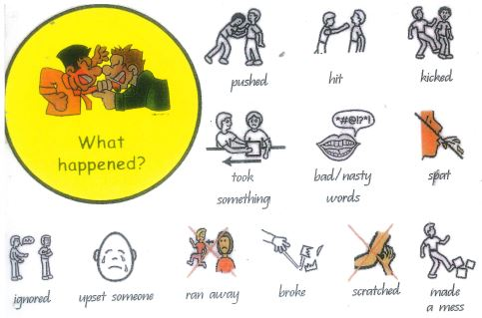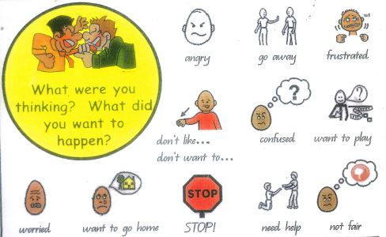
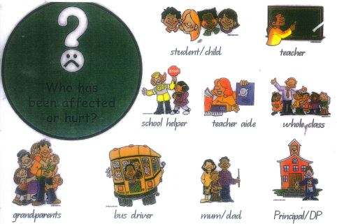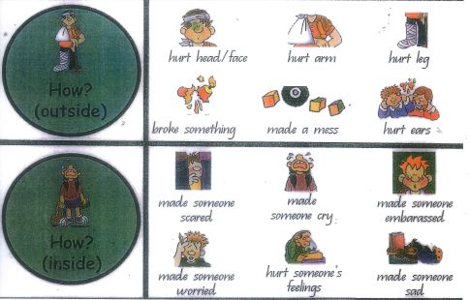

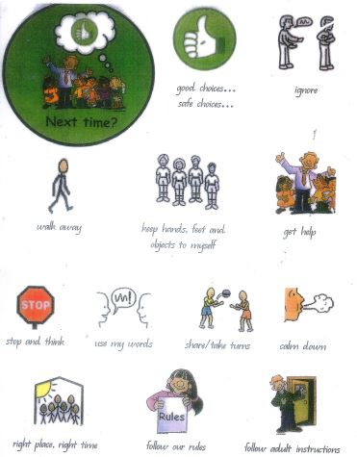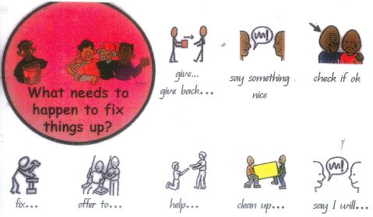
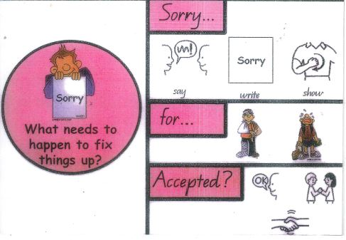

Differentiated and Explicit Teaching

Townsville Central State School is a disciplined school environment that provides Quality Differentiated Teaching Practices to respond to the learning needs of all students. This involves teaching expected behaviours and providing opportunities for students to practise these behaviours. Teachers reinforce expected behaviours, provide feedback and correction, and opportunities for practise.

Teachers at Townsville Central State School vary what students are taught, how they are taught and how students can demonstrate what they know as part of this differentiated approach to behaviour. These decisions about differentiation are made in response to data and day-to-day monitoring that indicates the behavioural learning needs of students. This enables our teachers to purposefully plan a variety of ways to engage students; assist them to achieve the expected learning; and to demonstrate their learning.

There are three main layers to differentiation, as illustrated in the diagram below. This model is the same used for academic and pedagogical differentiation.

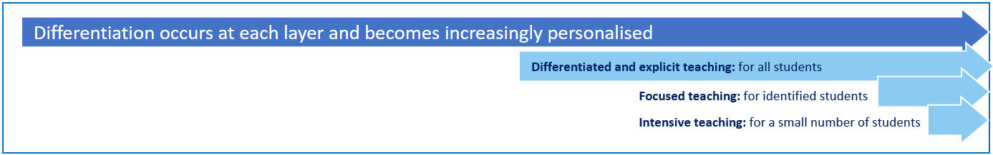

These three layers map directly to the tiered approach discussed earlier in the Learning and Behaviour section. For example, in the PBL framework, Tier 1 is differentiated and explicit teaching for all students, Tier 2 is focussed teaching for identified students and Tier 3 is intensive teaching for a small number of students. Each layer provides progressively more personalised supports for students.

Every classroom in our school uses the PBL Expectations Matrix, illustrated below, as a basis for developing their behaviour standards. Using this matrix, the class teacher works with all students to explain exactly what each of the expectations look, sound and feel like in their classroom. The completed matrix is on display in every classroom, used as the basis of teaching expectations throughout the year and revisited regularly to address any new or emerging issues.

Focused Teaching

Approximately 15% of all students in any school or classroom may require additional support to meet behaviour expectations, even after being provided with differentiated and explicit teaching. These students may have difficulty meeting behavioural expectations in a particular period of the day or as part of a learning area/subject, and focused teaching is provided to help them achieve success.

Focused teaching involves revisiting key behavioural concepts and/or skills and using explicit and structured teaching strategies in particular aspects of a behaviour skill. Focused teaching provides students with more opportunities to practise skills and multiple opportunities to achieve the intended learning and expected behaviour.

Support staff, including teachers with specialist expertise in learning, language or development, work collaboratively with class teachers at Townsville Central State School to provide focused teaching. Focused teaching is aligned to the PBL Expectations Matrix, and student progress is monitored by the classroom teacher/s to identify those who:
- no longer require the additional support
- require ongoing focussed teaching
- require intensive teaching.

Townsville Central State School has a range of Student Support Network staff in place to help arrange and deliver focused teaching to students who need more support to meet expectations. In addition, the school invests in the following evidence-informed supports to address specific skill development for some students:
- One-Page Profile
- Individual Positve Behaviour Support Plans
- Wellbeing Garden
- Functional Behaviour Assessment.

For more information about these programs, please speak with the Principal.

Intensive Teaching

Research evidence shows that even in an effective, well-functioning school there will always be approximately 5% of the student population who require intensive teaching to achieve behavioural expectations. Intensive teaching involves frequent and explicit instruction, with individuals or in small groups, to develop mastery of basic behavioural concepts, skills and knowledge.

Some students may require intensive teaching for a short period, for particular behaviour skills. Other students may require intensive teaching for a more prolonged period. Decisions about the approach will be made based on data collected from their teacher or teachers, and following consultation with the student’s family.

For a small number of students who continue to display behaviours that are deemed complex and challenging, then individualised, function-based behaviour assessment and support plans and multi-agency collaboration may be provided to support the student. This approach will seek to address the acute impact of barriers to learning and participation faced by students who are negotiating a number of complex personal issues.

Students who require intensive teaching may be assigned an individual mentor at the school that will oversee the coordination of their program, communicate with stakeholders and directly consult with the student.

Disciplinary Consequences

Townsville Central State School and our Parents and Citizens Association-run Out of School Hours Care facility make systematic efforts to prevent problem student behaviour by explicitly teaching and reinforcing expected behaviours on an ongoing basis. As part of our approach, Townsville Central State School strives to teach students that they are responsible for how they behave at all times. Students learn that consequences are a direct result of their actions. All staff encourage students to make appropriate behaviour choices and help them accept that consequences are a certainty for their actions.

Consequences are used to educate the student that his or her choice of behaviour is inappropriate. In applying consequences, the key action for the teacher is to use a restorative approach, to reflect with the student by discussing the right choices and the appropriate action for the time.

Our school seeks to ensure that responses to unacceptable behaviour are restorative,
consistent and proportionate to the nature of the behaviour. OneSchool is used to record all
major problem behaviour and some repetitive minor behaviours.

Minor and major behaviours
When responding to problem behaviour, the staff member first determines if the problem
behaviour is major or minor, with the following agreed understanding:
- Minor problem behaviour is handled by staff members at the time it happens; and
- Major problem behaviour is referred directly to administration.

Minor behaviours are those that:
- are minor breaches of the school rules;
- do not seriously harm others or cause you to suspect that the student may be harmed;
- do not violate the rights of others in any other serious way; or
- do not require involvement of specialist support staff or administration.

Minor problem behaviours may result in the following consequences:
- restorative conversation;
- a minor consequence logically connected to the problem behaviour, such as removal
from an activity or event for a specified period of time, temporary removal of property,
individual meeting with the student, apology, reflection, restitution or time for work
completion, private discussion with the student about expected behaviour;
- reflection time in another class; or
- a re-direction procedure.

The staff member may take the student aside and:
1. name the behaviour that student is displaying;
2. ask the student to name the expected school behaviour;
3. state and explain the expected school behaviour if necessary; and
4. give positive acknowledgement for demonstrating expected school behaviour.
- record as a OneSchool incident report and may referr to various staff.

Major behaviours are those that:
- significantly violate the rights of others;
- put others / self at risk of harm;
- require the involvement of school administration; and
- may require restorative conversations.

Major behaviours result in an immediate referral to administration via OneSchool or telephone call because of their seriousness. When major problem behaviour occurs, staff members calmly state the major problem behaviour and remind the student of expected school behaviour.

The school Principal works in consultation with the Student Support team to address persistent or ongoing serious problem behaviour. This may include a short or long term suspension (SDA).

A School Disciplinary Absence (SDA) is an enforced period of absence from attending a
Queensland state school, applied by the Principal as a consequence to address poor student behaviour. There are four types of SDA:
- Short suspension (1 to 10 school days)
- Long suspension (11 to 20 school days)
- Charge-related suspension
- Exclusion (period of not more than one year or permanently).

At Townsville Central State School, the use of any SDA is considered a very serious decision. It is typically only used by the Principal when other options have been exhausted or the student’s behaviour is so dangerous that continued attendance at the school is considered a risk to the safety or wellbeing of the school community.

Parents and students may appeal a long suspension, charge-related suspension or exclusion decision. A review will be conducted by the Director-General or their delegate, and a decision made within 40 schools days to confirm, amend/vary or set aside the original SDA decision by the Principal.

The appeal process is a thorough review of all documentation associated with the SDA
decision and provides an opportunity for both the school and the family to present their case
in the matter. Time is afforded for collection, dissemination and response to the materials by
both the school and the family. It is important that the purpose of the appeal is understood so
that expectations are clear, and appropriate supports are in place to ensure students can
continue to access their education while completing their SDA.

Differentiated

Class teachers provide in-class or in-school disciplinary responses to low-level or minor problem behaviour using the Essential Skills for Classroom Management (ESCM). This may include:
- ESCM Skill 1: ESTABLISHING EXPECTATIONS
- ESCM Skill 2: INSTRUCTION GIVING
- ESCM Skill 3: WAITING AND SCANNING
- ESCM Skill 4: CUEING WITH PARALLEL ACKNOWLEDGEMENT
- ESCM Skill 5: BODY LANGUAGE ENCOURAGING
- ESCM Skill 6: DESCRIPTIVE ENCOURAGING
- ESCM Skill 7: SELECTIVE ATTENDING
- ESCM Skill 8: REDIRECTING TO THE LEARNING
- ESCM Skill 9: GIVING A CHOICE
- ESCM Skill 10: FOLLOWING THROUGH
- DEBRIEFING / DEFUSING
- GAINING ATTENTION
- RE-ENTRY AFTER TIME OUT
Focussed

Class teachers are supported by other school-based staff to address in-class problem behaviour. This may include:
- Functional Behaviour Assessment
- Individual student behaviour support strategies (e.g. Student behaviour plan)
- Targeted skills teaching in small group
- Token economy (STARs)
- Reflection Room
- Behaviour contract and/or Playground Plan
- Counselling and guidance support
- Self-monitoring plan
- Check in Check Out strategy
- Teacher coaching and debriefing
- Referral to Student Support Network for team based problem solving
- Stakeholder meeting with parents and external agencies

Intensive

School leadership team work in consultation with Student Support Team to address persistent or ongoing serious problem behaviour. This may include:
- Functional Behaviour Assessment based individual support plan
- Complex case management and review within our MTSS
- Stakeholder meeting with parents and external agencies including regional specialists
- Temporary removal of student property (e.g. mobile phone)
- Short term suspension (up to 10 school days)
- Long term suspension (up to 20 school days)
- Charge-related suspension (student has been charged with a serious criminal offence is suspended from school until the charge has been dealt with by the relevant justice authorities)
- Suspension pending exclusion (student is suspended from school pending a decision by the Director-General or delegate (principal) about their exclusion from school)
- Exclusion (student is excluded from a particular state school site, a group of state schools or all state schools in Queensland for a defined period of time or permanently)
- Cancellation of enrolment for students older than compulsory school age who refuse to participate in the educational program provided at the school.

School Disciplinary Absences

A School Disciplinary Absence (SDA) is an enforced period of absence from attending a Queensland state school, applied by the Principal as a consequence to address poor student behaviour. There are four types of SDA:
- Short suspension (1 to 10 school days)
- Long suspension (11 to 20 school days)
- Charge-related suspension
- Exclusion (period of not more than one year or permanently).

At Townsville Central State School , the use of any SDA is considered a very serious decision. It is typically only used by the Principal when other options have been exhausted or the student’s behaviour is so dangerous that continued attendance at the school is considered a risk to the safety or wellbeing of the school community.

Parents and students may appeal a long suspension, charge-related suspension or exclusion decision. A review will be conducted by the Director-General or their delegate, and a decision made within 40 schools days to confirm, amend/vary or set aside the original SDA decision by the Principal.

The appeal process is a thorough review of all documentation associated with the SDA decision and provides an opportunity for both the school and the family to present their case in the matter. Time is afforded for collection, dissemination and response to the materials by both the school and the family. It is important that the purpose of the appeal is understood so that expectations are clear, and appropriate supports are in place to ensure students can continue to access their education while completing their SDA.

Re-entry following suspension
Students who are suspended from Townsville Central State School will usually be invited to attend a re-entry meeting on the day of/prior to their scheduled return to school. The main purpose of this meeting is to welcome the student, with their parent/s, back to the school. It is not a time to review the student’s behaviour or the decision to suspend, the student has already received a punishment through their disciplinary absence from school. The aim of the re-entry meeting is for school staff to set the student up for future success and strengthen home-school communication.

It is not mandatory for the student or their parents to attend a re-entry meeting. It is offered as a support for the student to assist in their successful re-engagement in school following suspension.

Arrangements
The invitation to attend the re-entry meeting will be communicated via telephone and email, usually via the SDA letter. Re-entry meetings are short, taking less than 20 minutes, and are kept small with only the Principal or their delegate attending with the student and their parent/s.

A record of the meeting is saved in OneSchool, under the Contact tab, including any notes or discussions occurring during the meeting.

Structure
The structure of the re-entry meeting should follow a set agenda, shared in advance with the student and their family. If additional items are raised for discussion, a separate arrangement should be made to meet with the parent/s at a later date and time. This meeting should be narrowly focussed on making the student and their family feel welcome back into the school community – what we call ‘repairing the relationship’. The restorative conversation cards may be used.

Possible agenda:
- Welcome back to school
- Check in on student wellbeing
- Discuss any recent changes to school routine or staffing
- Offer information about supports available (e.g. guidance officer)
- Set a date for follow-up if required
- Thank student and parent/s for attending
- Walk with student to classroom

Reasonable adjustments
In planning the re-entry meeting, school staff will consider reasonable adjustments needed to support the attendance and engagement of the student. This includes selecting an appropriate and accessible meeting space, organising translation or interpretation services or supports (e.g. AUSLAN), provision of written and/or pictorial information and other relevant accommodations. The inclusion of support staff, such as guidance officer or Community Education Counsellor or class teacher, may also offer important advice to ensure a successful outcome to the re-entry meeting.

School Policies
Townsville Central State School and its OSHC has tailored school discipline policies designed to ensure students, staff and visitors work cooperatively to create and maintain a supportive and safe learning environment. Please ensure that you familiarise yourself with the responsibilities for students, staff and visitors outlined in the following policies:

- Temporary removal of student property
- Use of mobile phones and other devices by students
- Preventing and responding to bullying
- Appropriate use of social media

Temporary removal of student property

The removal of any property in a student’s possession may be necessary to promote the caring, safe and supportive learning environment of the school, to maintain and foster mutual respect between all state school staff and students. The Temporary removal of student property by school staff procedure outlines the processes, conditions and responsibilities for state school principals and school staff when temporarily removing student property.

In determining what constitutes a reasonable time to retain student property, the principal or state school staff will consider:
- the condition, nature or value of the property
- the circumstances in which the property was removed
- the safety of the student from whom the property was removed, other students or staff members
- good management, administration and control of the school.
The Principal or state school staff determine when the temporarily removed student property can be returned, unless the property has been handed to the Queensland Police Service.

The following items are explicitly prohibited at Townsville Central State School and will be removed if found in a student’s possession:
- illegal items or weapons (e.g. guns, knives*, throwing stars, brass knuckles, chains)
- imitation guns or weapons
- potentially dangerous items (e.g. blades, rope)
- drugs** (including tobacco)
- alcohol
- aerosol deodorants or cans (including spray paint)
- explosives (e.g. fireworks, flares, sparklers)
- flammable solids or liquids (e.g. fire starters, mothballs, lighters)
- poisons (e.g. weed killer, insecticides)
- inappropriate or offensive material (e.g. racist literature, pornography, extremist propaganda).
- mobile phone
- vapes
* No knives of any type are allowed at school, including flick knives, ballistic knives, sheath knives, push daggers, trench knives, butterfly knives, star knives, butter knives, fruit knives or craft knives, or any item that can be used as a weapon, for example a chisel. Knives needed for school activities will be provided by the school, and the use of them will be supervised by school staff. In circumstances where students are required to have their own knives or sharp tools for particular subjects or vocational courses, the school will provide information about the procedures for carrying and storing these items at school.

** The administration of medications to students by school staff is only considered when a prescribing health practitioner has determined that it is necessary or when there is no other alternative in relation to the treatment of a specific health need. Schools require medical authorisation to administer any medication to students (including over-the-counter medications such as paracetamol or alternative medicines).

Responsibilities

State school staff at Townsville Central State School:
- do not require the student’s consent to search school property such as lockers, desks or laptops that are supplied to the student through the school;
- may seize a student’s bag where there is suspicion that the student has a dangerous item (for example, a knife) in their school bag, prior to seeking consent to search from a parent or calling the police;
- consent from the student or parent is required to examine or otherwise deal with the temporarily-removed student property. For example, staff who temporarily remove a mobile phone from a student are not authorised to unlock the phone or to read, copy or delete messages stored on the phone;
- there may, however, be emergency circumstances where it is necessary to search a student’s property without the student’s consent or the consent of the student’s parents (e.g. to access an EpiPen for an anaphylactic emergency);
- consent from the student or parent is required to search the person of a student (e.g. pockets or shoes). If consent is not provided and a search is considered necessary, the police and the student’s parents should be called to make such a determination.

Parents and Carers of students at Townsville Central State School
- ensure your children do not bring property onto schools grounds or other settings used by the school (e.g. camp, sporting venues) that:
  - is prohibited according to the Townsvile Central State School Student Code of Conduct;
  - is illegal;
  - puts the safety or wellbeing of others at risk;
  - does not preserve a caring, safe, supportive or productive learning environment;
  - does not maintain and foster mutual respect;
- collect temporarily removed student property as soon as possible after they have been notified by the Principal or state school staff that the property is available for collection.

Students of Townsville Central State School
- do not bring property onto school grounds or other settings used by the school (e.g. camp, sporting venues) that:
  - is prohibited according to the Exemplar State College Code of Conduct;
  - is illegal;
  - puts the safety or wellbeing of others at risk;
  - does not preserve a caring, safe, supportive or productive learning environment;
  - does not maintain and foster mutual respect;
- collect their property as soon as possible when advised by the Principal or state school staff it is available for collection.

Use of mobile phones and other devices by students

Digital literacy refers to the skills needed to live, learn and work in a society where communication and access to information is dominated by digital technologies like mobile phones. However, the benefits brought about through these diverse technologies can be easily overshadowed by deliberate misuse which harms others or disrupts learning.

In consultation with the broader school community, Townsville Central State School has determined that explicit teaching of responsible use of devices is a critical component of digital literacy. The knowledge and confidence to navigate and use these technologies safely while developing digital literacy is a responsibility shared between parents, school staff and students.

It is also agreed that time and space should be provided at school where technology is not permitted, and students are encouraged to engage in other social learning and development activities. Students, parents and visitors may see posters, such as the example below, around the school that clearly identify our technology-free zones and times. Please respect the expectations for these spaces and behaviours.

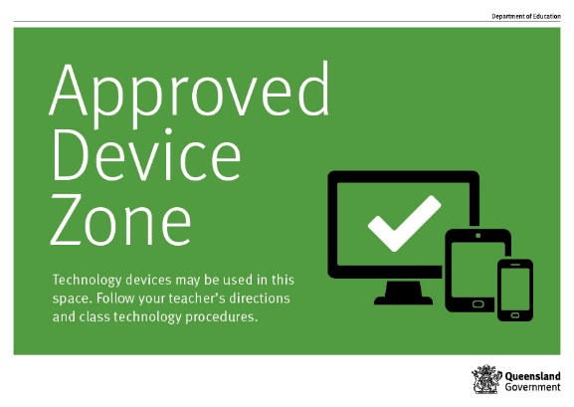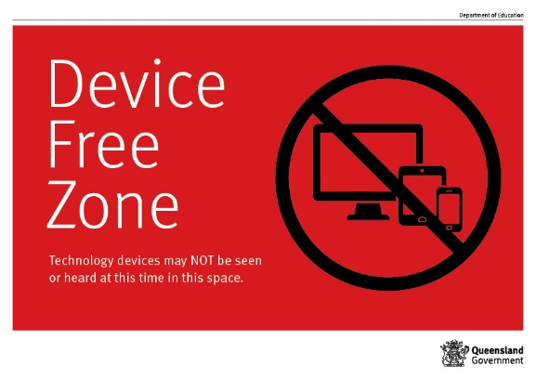

Responsibilities

The responsibilities for students using mobile phones or other devices at school or during school activities, are outlined below.

It is expected that students at Townsville Central State School will:
- switch off and hand in the mobile device at the front office uponi arriving at school
- sign in their device at tehs tart of the day, and sign out their device at the end of the day.

It is unacceptable for students at Townsville Central State School to:
- use a mobile phone or other devices in an unlawful manner
- use a mobile phone during the school day or times
- download, distribute or publish offensive messages or pictures
- use obscene, inflammatory, racist, discriminatory or derogatory language
- use language and/or threats of violence that may amount to bullying and/or harassment, or even stalking
- insult, harass or attack others or use obscene or abusive language
- take pictures or recordings of students in uniform and/or staff without their knowledge or permission
- deliberately waste printing and internet resources
- damage computers, ipads, printers or network equipment
- commit plagiarism or violate copyright laws
- ignore teacher directions for the use of social media, online email and internet chat
- send chain letters or spam email (junk mail)
- knowingly download viruses or any other programs capable of breaching the department's network security
- use in-phone cameras anywhere a normal camera would be considered inappropriate, such as in change rooms or toilets
- invade someone's privacy by recording personal conversations or daily activities and/or the further distribution (e.g. forwarding, texting, uploading, Bluetooth use etc.) of such material
- use a mobile phone (including those with Bluetooth functionality) to cheat during exams or assessments
- take into or use mobile devices at exams or during class assessment unless expressly permitted by school staff.

At all times students, while using ICT facilities and devices supplied by the school, will be required to act in line with the requirements of the Townsville Central State School Student Code of Conduct. In addition students and their parents should:
- understand the responsibility and behaviour requirements (as outlined by the school) that come with accessing the department’s ICT network facilities
- ensure they have the skills to report and discontinue access to harmful information if presented via the internet or email
- be aware that:
  - access to ICT facilities and devices provides valuable learning experiences for students and supports the school's teaching and learning programs
  - the school is not responsible for safeguarding information stored by students on departmentally-owned student computers or mobile devices
  - schools may remotely access departmentally-owned student computers or mobile devices for management purposes
  - students who use a school's ICT facilities and devices in a manner that is not appropriate may be subject to disciplinary action by the school, which could include restricting network access
  - despite internal departmental controls to manage content on the internet, illegal, dangerous or offensive information may be accessed or accidentally displayed
  - staff will always exercise their duty of care, but avoiding or reducing access to harmful information also requires responsible use by the student.

Preventing and responding to bullying

Townsville Central State School uses the Australian Student Wellbeing Framework as an influence on our Student Learning and Wellbeing Framework to promote positive relationships and the wellbeing of all students, staff and visitors at the school.

Our staff know student learning is optimised when they feel connected to others and experience safe and trusting relationships. Students who feel secure are more likely to be active participants in their learning and to achieve better physical, emotional, social and educational outcomes. Teachers who feel valued and supported are more likely to engage positively with students and build stronger connections within the school community. Parents who are positively engaged with their child’s education leads to improved student self-esteem, attendance and behaviour at school. Enhancing the wellbeing of students and their educators delivers overall long-term social, health and economic benefits to the Australian community.

Townsville Central State School has a Student Leadership Forum called the Student Council. They meet regularly with a member of staff to promote strategies to improve student wellbeing, safety and learning outcomes. The standing items on the agenda for each Student Leadership Forum may be related to the core elements of the Australian Student Wellbeing Framework:

- Leadership
Principals and school leaders playing an active role in building a positive learning environment where the whole school community feels included, connected, safe and respected.

- Inclusion
All members of the school community actively participating in building a welcoming school culture that values diversity, and fosters positive, respectful relationships.

- Student voice
Students actively participate in their own learning and wellbeing, feel connected and use their social and emotional skills to be respectful, resilient and safe.
- Partnerships
Families and communities collaborating as partners with the school to support student learning, safety and wellbeing.

- Support
School staff, students and families sharing and cultivating an understanding of wellbeing and positive behaviour and how this supports effective teaching and learning.

A priority for the Student Council is contributing to the implementation of strategies that enhance wellbeing, promote safety and counter violence, bullying and abuse in all online and physical spaces.

At Townsville Central State School we believe students should be at the forefront of advising staff, parents and the broader community about emerging issues and practical solutions suitable to different contexts.

Bullying

The agreed national definition for Australian schools describes bullying as
- ongoing and deliberate misuse of power in relationships through repeated verbal, physical and/or social behaviour that intends to cause physical, social and/or psychological harm;
- involving an individual or a group misusing their power, or perceived power, over one or more persons who feel unable to stop it from happening;
- happening in person or online, via various digital platforms and devices and it can be obvious (overt) or hidden (covert). Bullying behaviour is repeated, or has the potential to be repeated, over time (for example, through sharing of digital records);
- having immediate, medium and long-term effects on those involved, including bystanders. Single incidents and conflict or fights between equals, whether in person or online, are not defined as bullying.

The High Five

Townsville Central State School teaches students to use the High Five to solve their problems appropriately every day. The High Five is based on Australia’s anti-bullying strategies. This image (below) is used to reinforce these positive strategies for problem-solving:

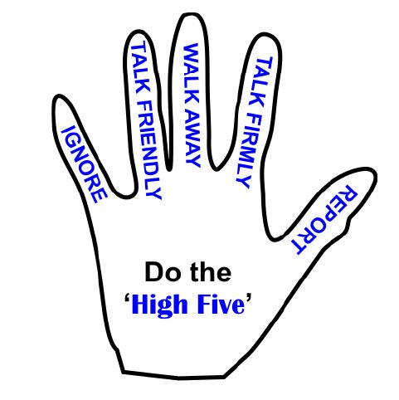

Behaviours that do not constitute bullying include:
- mutual arguments and disagreements (where there is no power imbalance);
- not liking someone or a single act of social rejection;
- one-off acts of meanness or spite;
- isolated incidents of aggression, intimidation or violence.

This poster is used to highlight the difference between negative behaviours and bullying:

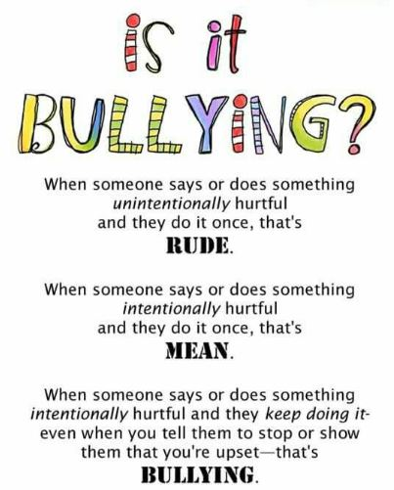

However, these conflicts are still considered serious and need to be addressed and resolved. At Townsville Central State School, our staff will work to quickly respond to any matters raised of this nature in collaboration with students and parents.

The following flowchart explains the actions Townsville Central State School staff will take when they receive a report about student bullying, including bullying which may have occurred online or outside of the school setting. Please note that the indicative timeframes will vary depending on the professional judgment of staff who receive the bullying complaint and their assessment of immediate risk to student/s.

Townsville Central State School - Bullying response flowchart for staff

Please note these timelines may be adjusted depending on the unique circumstances and risk associated with each situation. This is at the professional judgment of the staff involved. Timeframes should be clearly discussed and agreed with student and family.

Key contacts for students and parents to report bullying:
Prep to Year 6 – Class teacher
Principal – Ph : 47226333 Email :principal@townsvillecentralss.eq.edu.au

First hour
Listen
- Provide a safe, quiet space to talk
- Reassure the student that you will listen to them
- Let them share their experience and feelings without interruption
- If you hold immediate concerns for the student's safety, let the student know how you will address these. Immediate in this circumstance is where the staff member believes the student is likely to experience harm (from others or self) within the next 24 hours
- Ask the student for examples they have of the alleged bullying (e.g. hand written notes or screenshots)
- Write a record of your communication with the student
- Check back with the student to ensure you have the facts correct
- Enter the record in OneSchool
- Notify parent/s that the issue of concern is being investigated
Day one
Document
- Gather additional information from other students, staff or family
- Review any previous reports or records for students involved
- Make sure you can answer who, what, where, when and how
- Clarify information with student and check on their wellbeing
Day two
Collect
- Meet with the student to review situation
- Discuss what has changed, improved or worsened
- Explore other options for strengthening student wellbeing or safety
- Report back to parent
- Record outcomes in OneSchool
Day five
Review
- Continue to check in with student on regular basis until concerns have been mitigated
- Record notes of follow-up meetings in OneSchool
- Refer matter to specialist staff within 48 hours if problems escalate
- Look for opportunities to improve school wellbeing for all students
Ongoing
Follow up
- Evaluate the information to determine if bullying has occurred or if another disciplinary matter is at issue
- Make a time to meet with the student to discuss next steps
- Ask the student what they believe will help address the situation
- Engage the student as part of the solution
- Provide the student and parent with information about student support network
- Agree to a plan of action and timeline for the student, parent and yourself
Day three
Discuss
- Document the plan of action in OneSchool
- Complete all actions agreed with student and parent within agreed timeframes
- Monitor student and check in regularly on their wellbeing
- Seek assistance from student support network if needed
Day four
Implement
Cyberbullying

Cyberbullying is treated at Townsville Central State School with the same level of seriousness as in-person bullying. The major difference with cyberbullying however, is that unlike in-person bulling, cyberbullying follows students into their community, their homes and their bedrooms, giving them no opportunity to escape the harassment or abuse during the evening, weekends or holidays.

In the first instance, students or parents who wish to make a report about cyberbullying should approach the regular class teacher. The Principal can also be approached directly by students, parents or staff for assistance in preventing and responding to cyberbullying.

It is important for students, parents and staff to know that state school principals have the authority to take disciplinary action to address student behaviours that occur outside of school hours or school grounds. This includes cyberbullying. Parents and students who have concerns about cyberbullying incidents occurring during school holidays should immediately seek assistance through the Office of the e-Safety Commissioner or the Queensland Police Service.

Students enrolled at Townsville Central State School may face in-school disciplinary action, such as detention or removing of privileges, or more serious consequences such as suspension or exclusion from school for engaging in behaviour that adversely affects, or is likely to adversely affect, other students or the good order and management of the school. This includes behaviour such as cyberbullying which occurs outside of school hours or settings, for example on the weekend or during school holidays. It also applies to inappropriate online behaviour of enrolled students that is directed towards other community members or students from other school sites.

Parents or other stakeholders who engage in inappropriate online behaviour towards students, staff or other parents may be referred to the Office of the e-Safety Commissioner and/or the Queensland Police Service. State school staff will be referred for investigation to the Integrity and Employee Relations team in the Department of Education. Any questions or concerns about the school process for managing or responding to cyberbullying should be directed to the Principal.

Townsville Central State School - Cyberbullying response flowchart for school staff

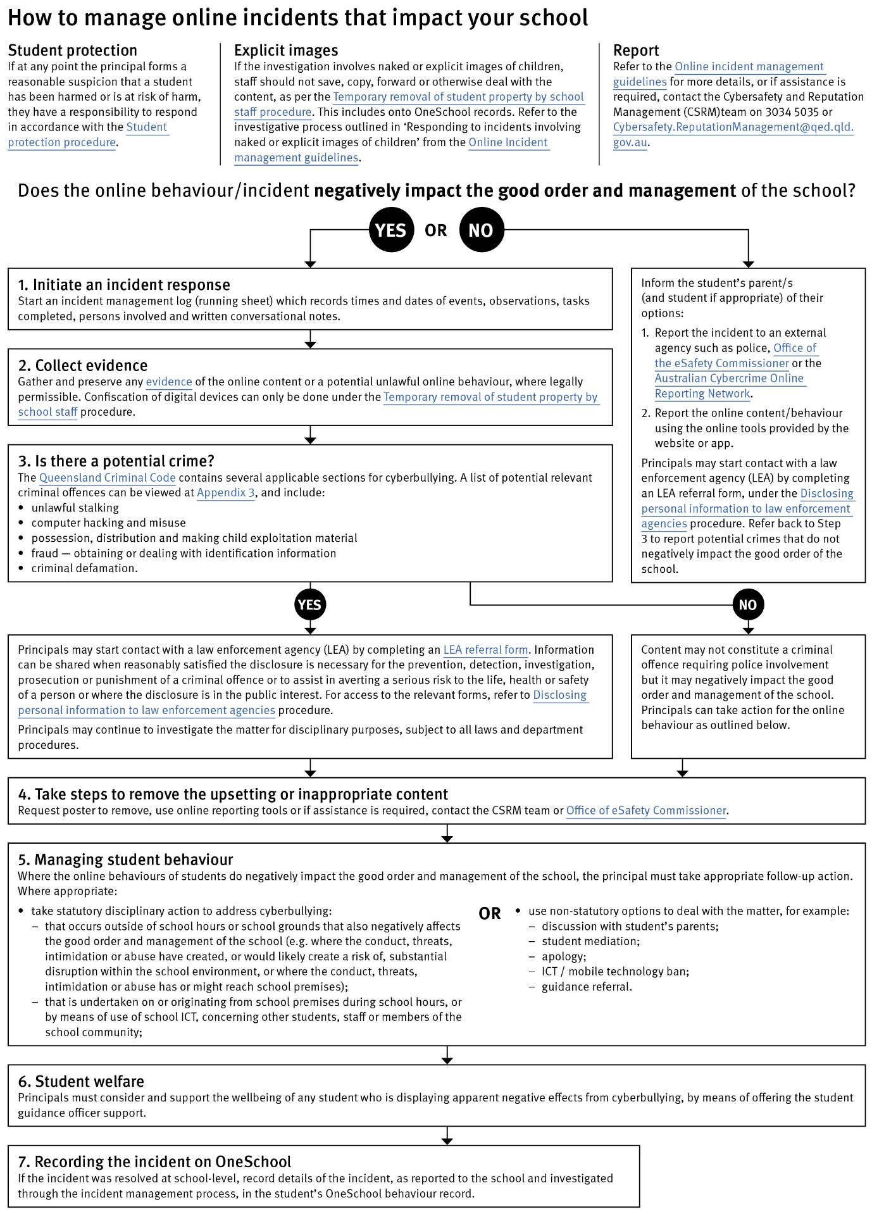

Cybersafety and Reputation Management (CRM)

The Department of Education employs a dedicated team of experts to assist in maintaining the integrity of the department's reputation with regards to cybersafety and reputation management issues, effectively leading the development and implementation of departmental cybersafety processes.

This team provides direct support for schools to respond to concerns of inappropriate online behaviour and misuse of information and communication technology.

The team provides a guide for parents with important information about cybersafety and cyberbullying, and suggestions about what you can do if your child is a target or responsible for inappropriate online behaviour.

The team has also developed a Cyberbullying and reputation management (Department employees only) resource to assist principals in incident management.

For more information about cybersafety sessions at your school, or for assistance with issues relating to online behaviour, contact the team (Department employees only).

Student Intervention and Support Services

Townsville Central State School recognises the need to provide intervention and support to all students involved in incidents of bullying, including cyberbullying.

Students who have been subject or witness to bullying have access to a range of internal support staff, as identified in the Student Support Team section earlier in this document. Students are, however, also encouraged to approach any staff member with whom they feel comfortable sharing their concerns, regardless of their role in the school. All staff at Townsville Central State School are familiar with the response expectations to reports of bullying, and will act quickly to ensure students’ concerns are addressed. Depending on the nature of the reported bullying incident, a formal plan of action may be developed and documented to support the implementation of strategies to assist the student.

Students who engage in bullying behaviours towards others will also be provided with support to assist them to use more socially acceptable and appropriate behaviours in their interactions. This includes counselling, social development programs, referral to mental health services or involvement in a restorative practices strategy. School disciplinary measures may also be used to reinforce the seriousness with which the community takes all incidents of bullying. These measures may include internal school suspension, withdrawal from social events or celebrations or more severe punishments such as suspension or exclusion from school.
Townsville Central State School – Anti-Bullying Contract

The Anti-Bullying Compact provides a clear outline of the way our community at Townsville Central State School works together to establish a safe, supportive and disciplined school environment. This compact is provided to all students and their parents upon enrolment, and may be revisited with individual students if particular problems around bullying arise.

Townsville Central State School – Anti Bullying Contract

We agree to work together to improve the quality of relationships in our community at Townsville Central State School. It is through intentional consideration of our behaviour and communication that we can reduce the occurrence of bullying, and improve the quality of the schooling experience for everyone.

The agreed national definition for Australian schools describes bullying as
- ongoing and deliberate misuse of power in relationships through repeated verbal, physical and/or social behaviour that intends to cause physical, social and/or psychological harm;
- involving an individual or a group misusing their power, or perceived power, over one or more persons who feel unable to stop it from happening;
- happening in person or online, via various digital platforms and devices and it can be obvious (overt) or hidden (covert). Bullying behaviour is repeated, or has the potential to be repeated, over time (for example, through sharing of digital records);
- having immediate, medium and long-term effects on those involved, including bystanders. Single incidents and conflict or fights between equals, whether in person or online, are not defined as bullying.

We believe that no one deserves to be mistreated and that everyone regardless of race, colour, religion, immigration status, nationality, size, gender, popularity, athletic capability, academic outcomes, social ability, or intelligence has the right to feel safe, secure, and respected.

I agree to:
- Treat everyone with kindness and respect.
- Abide by the school’s anti-bullying policies and procedures.
- Support individuals who have been bullied.
- Speak out against verbal, relational, physical bullying and cyber bullying.
- Notify a parent, teacher, or school administrator when bullying does occur.

Student’s signature

Parent’s signature

School representative signature
Date

Appropriate use of social media

The internet, mobile phones and social media provide wonderful opportunities for students to network and socialise online. While these technologies provide positive platforms for sharing ideas, they also have the potential to cause pain and suffering to individuals, groups or even whole communities.

It’s important to remember that sometimes negative comments posted about the school community have a greater impact than expected. This guide offers some information about how to use social media in relation to comments or posts about the school community. Reputations of students, teachers, schools, principals and even parents can be permanently damaged — and in some cases, serious instances of inappropriate online behaviour are dealt with by police and the court system.

Being aware of a few simple strategies can help keep the use of social media positive and constructive:
- Before you post something online, ask yourself if the community or individual really need to know. Is it relevant, positive and helpful?
- Remember that what you post online is a direct reflection of who you are. People will potentially form lasting opinions of you based on what you post online.
- Be a good role model. If things get heated online consider logging out and taking a few moments to relax and think. Hasty, emotive responses could inflame situations unnecessarily.
- Be mindful when commenting, try to keep general and avoid posting anything that could identify individuals.
- A few years ago parents may have discussed concerns or issues with their friends at the school gate. Today with the use of social media, online discussions between you and your close friends can very quickly be shared with a much wider audience, potentially far larger than intended.
- Taking a few moments to think about the content you are about to post could save upset, embarrassment, and possible legal action.
- As a parent you have a role in supervising and regulating your child’s online activities at home and its impact on the reputation and privacy of others. Parents are their child’s first teachers — so they will learn online behaviours from you.

Is it appropriate to comment or post about schools, staff or students?

Parental and community feedback is important for schools and the department. If you have a compliment, complaint or enquiry about an issue at school, the best approach is to speak directly to the school about the matter, rather than discussing it in a public forum.

While many schools use social media to update parents of school notices, the department prefers that parents contact schools directly with a compliment, complaint or enquiry due to privacy considerations. Imagine if your doctor, accountant or banking institution tried to contact you to discuss important matters via Facebook.

If you have raised an issue with a school or know that another person has, consider refraining from discussing those details on social media, particularly the names of anyone involved.

Keep comments calm and polite, just as you would over the telephone or by email. If you encounter negative or derogatory content online which involves the school, hinders a child’s learning and/or affects the school community at large, contact the school principal.

Possible civil or criminal ramifications of online commentary

A serious instance of inappropriate online behaviour may constitute a criminal offence and become a police matter. For example, online content may substantiate the offence of ‘using a carriage service to menace, harass or cause offence’ (Criminal Code Act 1995 (Cth) s. 474.17). School staff may contact their union or obtain personal legal advice if they feel that online content seriously impacts their reputation. Defamatory online content may give rise to litigation under the Defamation Act 2005 (Qld).

What about other people’s privacy?

If you upload photos of your children, be mindful of who might be in the background. You might be happy to share your child’s successes with your friends and family via social media, but some parents are not. If you are tagging or naming students, consider that other parents may not want their child’s name attached to images online.

What if I encounter problem content?

Taking the following steps may help resolve the issue in a constructive way:
- refrain from responding
- take a screen capture or print a copy of the concerning online content
- if you consider problem content to be explicit, pornographic or exploitative of minors, you should keep a record of the URL of the page containing that content but NOT print or share it. The URL can be provided to the school principal, or police, as needed for escalation of serious concerns
- block the offending user
- report the content to the social media provider.

Restrictive Practices
School staff at Townsville Central State School need to respond to student behaviour that presents a risk of physical harm to the student themselves or others. It is anticipated that most instances of risky behaviour can be de-escalated and resolved quickly. On some rarer occasions, a student’s behaviour may continue to escalate and staff need to engage immediately with positive and proactive strategies aimed at supporting the student to manage their emotional arousal and behaviour.

In some very rare situations, where there is immediate risk of physical harm to the student or other people, and when all other alternative strategies have failed to reduce the risk, it may be necessary for staff to use restrictive practices.

The use of restrictive practices will always be as a last resort, when there is no other available option for reducing immediate risk to the student, staff or other people. Restrictive practices are not used for punishment or as a disciplinary measure.

The department’s Restrictive practices procedure is written with consideration for the protection of everyone’s human rights, health, safety and welfare. There are six fundamental principles:

- Regard to the human rights of those students
- Safeguards students, staff and others from harm
- Ensures transparency and accountability
- Places importance on communication and consultation with parents and carers
- Maximises the opportunity for positive outcomes, and
- Aims to reduce or eliminate the use of restrictive practices.

Very rarely restrictive practices will be planned and staff will employ, when necessary, pre-arranged strategies and methods (of physical restraint/ mechanical restraint/ clinical holding) which are based upon behaviour risk assessment or clinical health need and are recorded in advance. The use of planned strategies will only be where there is foreseeable immediate risk consistent with the Restrictive practices procedure.

Seclusion will not be used as a planned response and will only be used in serious circumstances for managing an unforeseeable situation in an emergency. It will be used for the shortest time possible and in a safe area that presents no additional foreseeable risk to the student. In such emergencies, a staff member will observe the student at all times and seclusion will cease as soon as possible.

Following the use of any restrictive practice, a focused review will help staff to understand how they responded to the risk in any incident that involved the use of a restrictive practice. Staff will consider whether there are other options for managing a similar situation in the future. This strategy works well for reducing the use of restrictive practices.

All incidents of restrictive practices will be recorded and reported in line with departmental procedures.

Critical Incidents
It is important that all school staff have a consistent understanding of how to respond in emergencies involving student behaviour that seriously endangers the student or others. This consistency ensures that appropriate actions are taken to ensure that both students and staff are kept safe.

A critical incident is defined as an occurrence that is sudden, urgent, and usually unexpected, or an occasion requiring immediate action (e.g. in the community, on the road). The aim in these situations is to bring the behaviour of the student under rapid and safe control. It is not a time to try and to punish or discipline the student; it is a crisis management period only.

Staff should follow the documented plan for any student involved in regular critical incidents, which should be saved and available for staff to review in OneSchool.

For unexpected critical incidents, staff should use basic defusing techniques:

- Avoid escalating the problem behaviour: Avoid shouting, cornering the student, moving into the student’s space, touching or grabbing the student, sudden responses, sarcasm, becoming defensive, communicating anger and frustration through body language.

- Maintain calmness, respect and detachment: Model the behaviour you want students to adopt, stay calm and controlled, use a serious measured tone, choose your language carefully, avoid humiliating the student, be matter of fact and avoid responding emotionally.

- Approach the student in a non-threatening manner: Move slowly and deliberately toward the problem situation, speak privately to the student/s where possible, speak calmly and respectfully, minimise body language, keep a reasonable distance, establish eye level position, be brief, stay with the agenda, acknowledge cooperation, withdraw if the situation escalates.

- Follow through: If the student starts displaying the appropriate behaviour briefly acknowledge their choice and re-direct other students’ attention towards their usual work/activity. If the student continues with the problem behaviour, then remind them of the expected school behaviour and identify consequences of continued unacceptable behaviour.

- Debrief: At an appropriate time when there is low risk of re-escalation, help the student to identify the sequence of events that led to the unacceptable behaviour, pinpoint decision moments during the sequence of events, evaluate decisions made, and identify acceptable decision options for future situations

Appendices

Examples of school mascot Curtis the Cockatoo used in PCL posters to promote expected positive behaviour
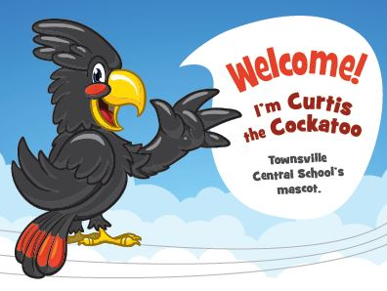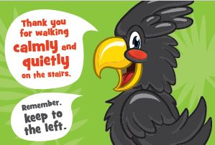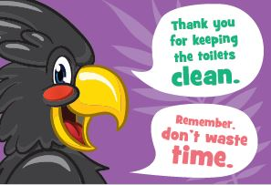

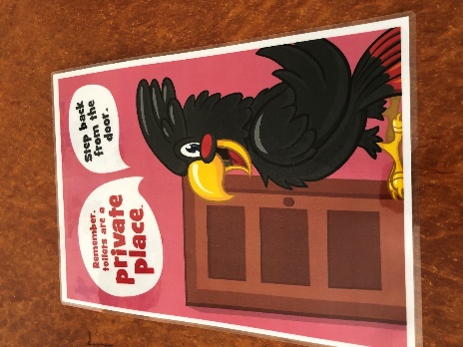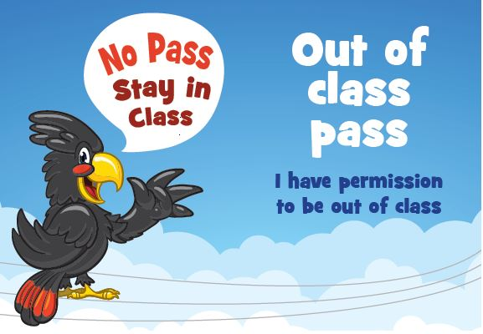

Example of Clubs at Central poster schedule
